1. For Each Department, Sort the Data on Manager ID and Emp_ID Desc

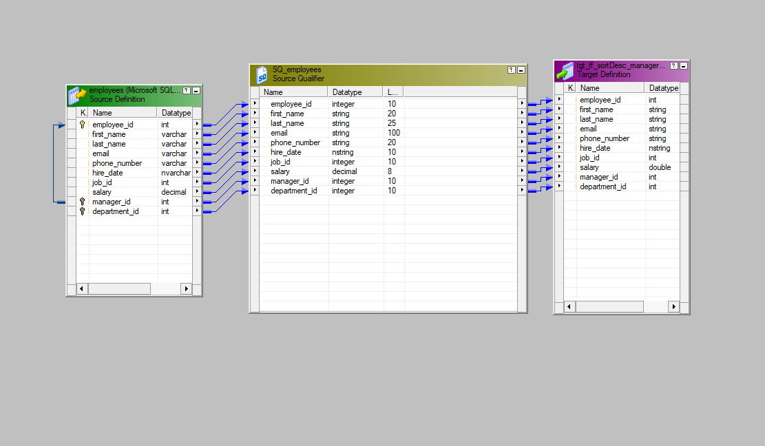

1. Location and Region Data Extract Using Source Qualifier SQL Override and Load into Target File

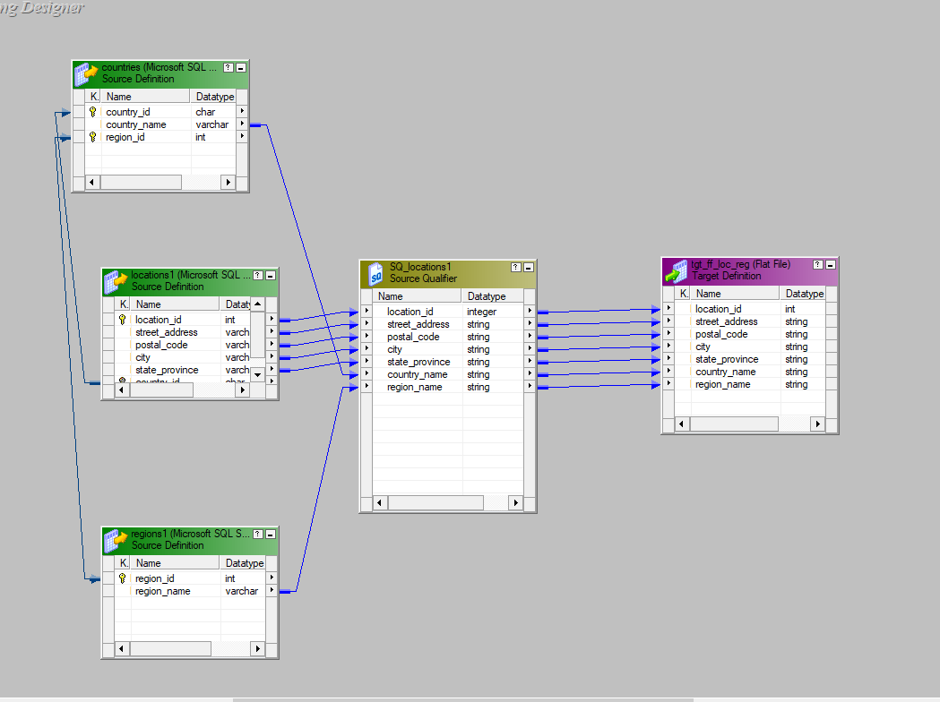

1. Get the Manager Name, Manager Email ID Domain, Max/Min/Avg Salary of Employees Under That Manager, and Load Date

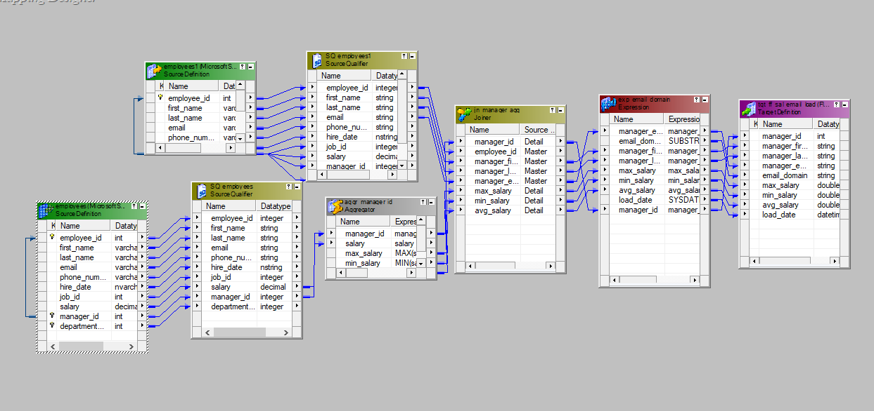

1. Get Top Salary Employee Under Each Manager

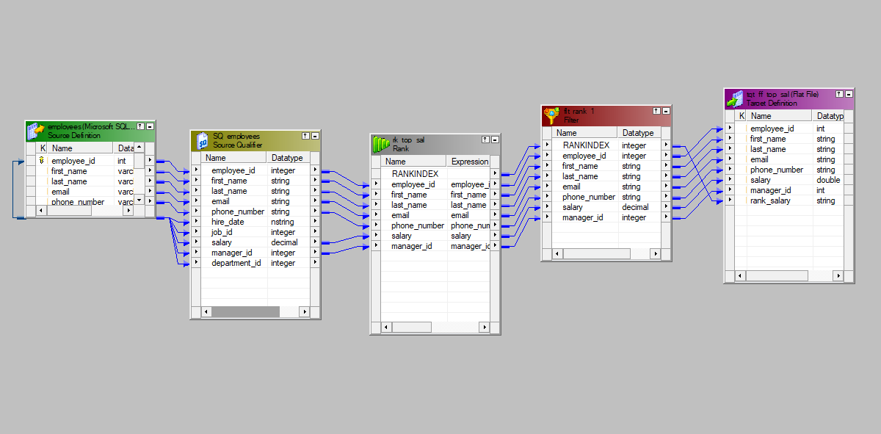

1. Get Employee ID, Full Name, Department Name, Location Details, Country Details, Region Details, Job Details Using Joiner

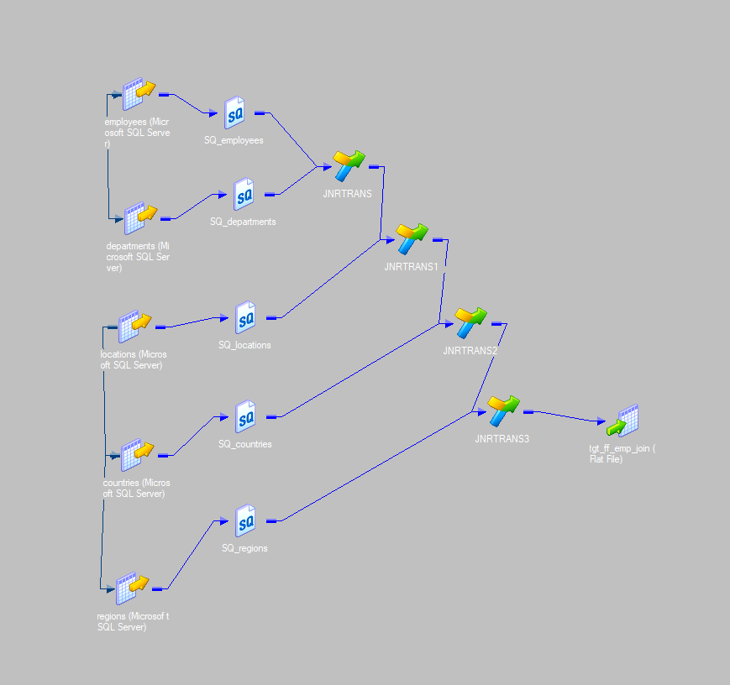

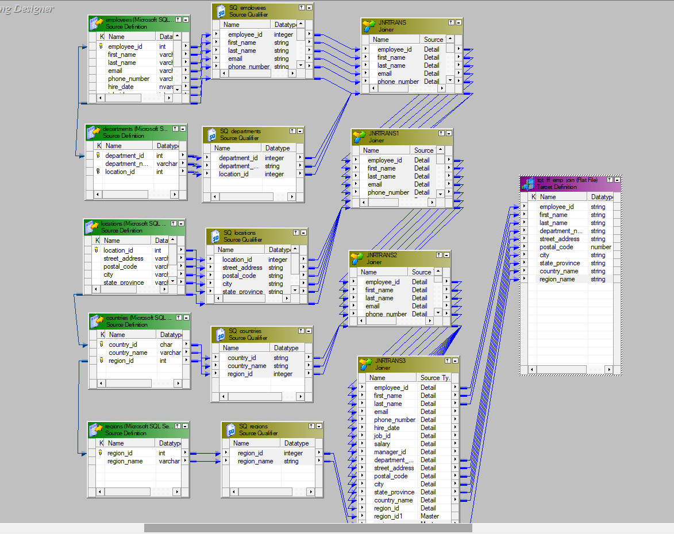

6. Get Employee Name and Dependent Count Using Aggregator and Lookup ○ Use a Lookup Transformation to retrieve dependent details for each employee. ○ Use an Aggregator Transformation to count the dependents per employee.

